Full Stack Developer - Coding Assignment

Download the bootstrap template using below link

<https://drive.google.com/file/d/15U_NjKMxwVcKsYV3IbqsshPq_olhylw2/view?usp=sharing>

### Task -1 : Integrate the following pages with codeigniter framework

1. Index.html
2. Blog-detail.html
3. blog.html

### Task 2 : On the Home page, replace Download with Registration Button



1. On click of Register button, a modal must appear and it must contain the following fields
   1. Name
   2. Email
   3. Phone
   4. Address
2. The modal must be aligned center as shown in below image

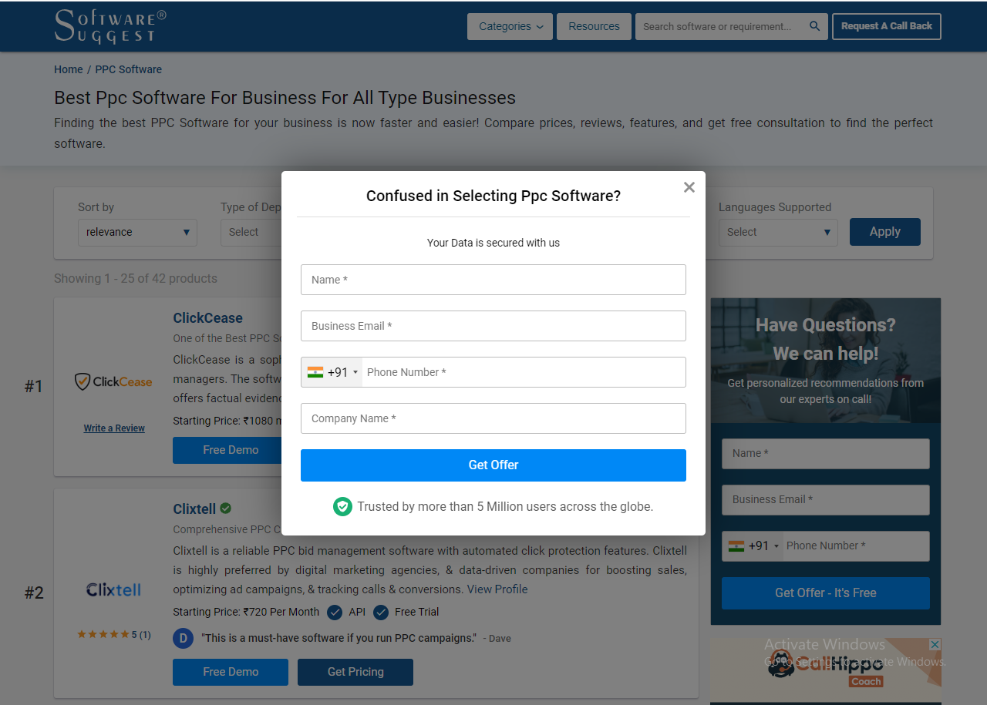

1. Perform form validation using AJAX and submit the form request to controller using a POST request
2. Create a database in phpmyadmin and integrate it with codeigniter template
3. Create a new table called member
4. Save the registration form details into a member table
5. Display count of users who has registered in home page , count should updated after every successful registration.

### Task 2 : Update the home page as per the instructions given below

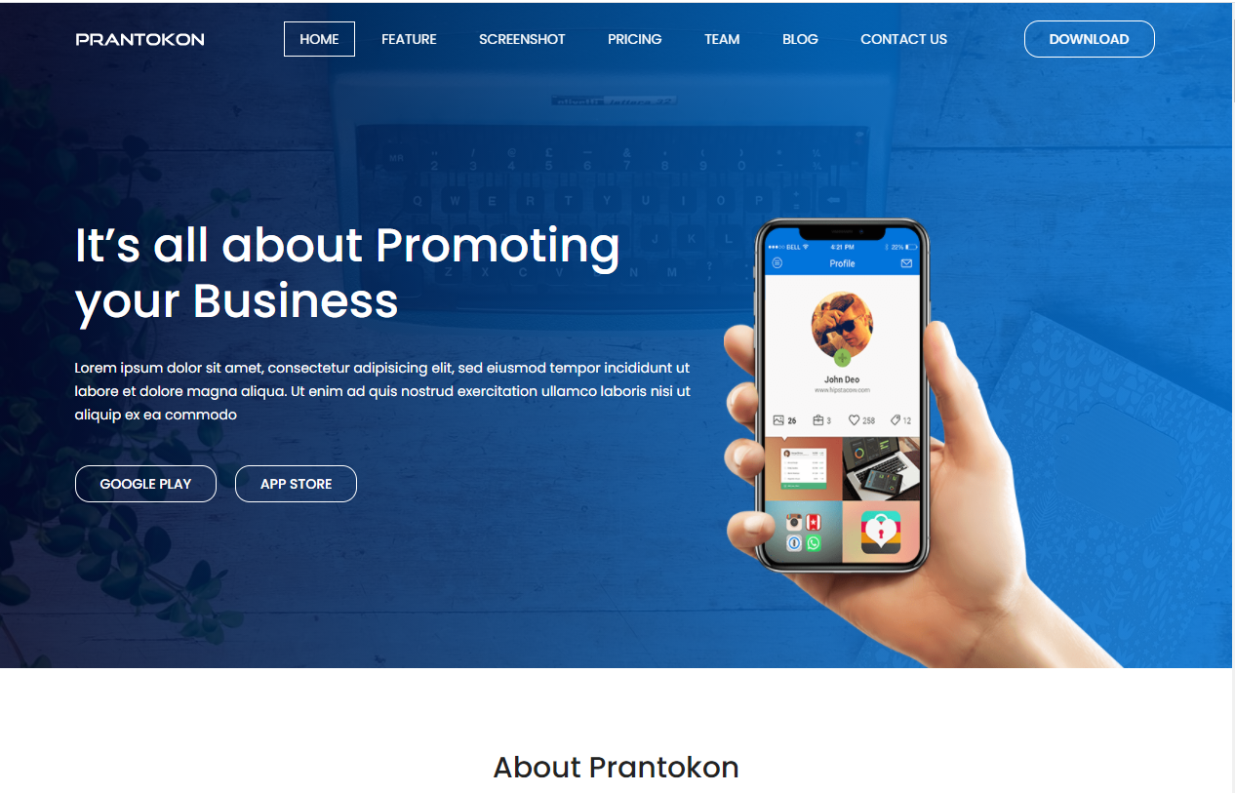

1. Add a sticky footer in the bottom as shown below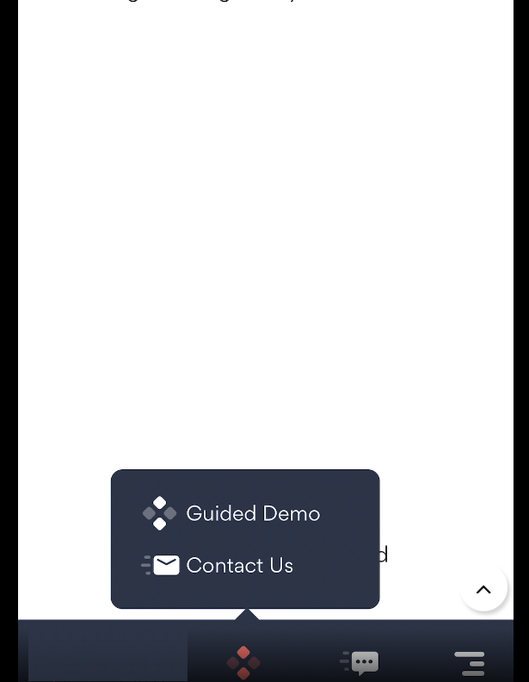

The sticky footer must be visible only in mobile browsers.

Here is the video for sticky footers for your reference.

<https://drive.google.com/file/d/1JHuAYYDc9ThSew665sCbN9PiSEjhkdbz/view?usp=sharing>

1. Modify the page to make it a landing Page. It must contain minimum of following sections:
2. Company Logo
3. Offerings
4. Features
5. Client Testimonials
6. Why choose us ?
7. Rating & Recognitions

Refer to below Website for content

<https://globalmlmsolution.com/>

Sample Landing Pages are provided below. Refer to below sample pages and design a Landing Page

<https://www.zendesk.com/>



<https://home.sophos.com/en-us.aspx>

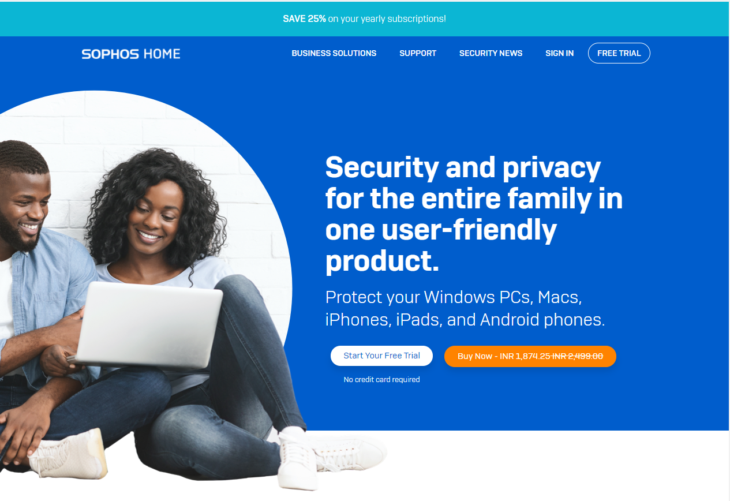

For product feature

<https://www.surveymonkey.com/welcome/employee-enterprise/?program=7013A000000ih75QAA&utm_bu=SME&utm_campaign=71700000079696142&utm_adgroup=58700006705097945&utm_content=43700060682603532&utm_medium=cpc&utm_source=adwords&utm_term=p60682603532&utm_kxconfid=s4bvpi0ju&gclid=Cj0KCQiAnKeCBhDPARIsAFDTLTJpyTlRvId0ixgJh8mIDvAT7SysLOeWaBHzRCbGrgtoX-Yw6UktNGkaAvAxEALw_wcB&gclsrc=aw.ds>

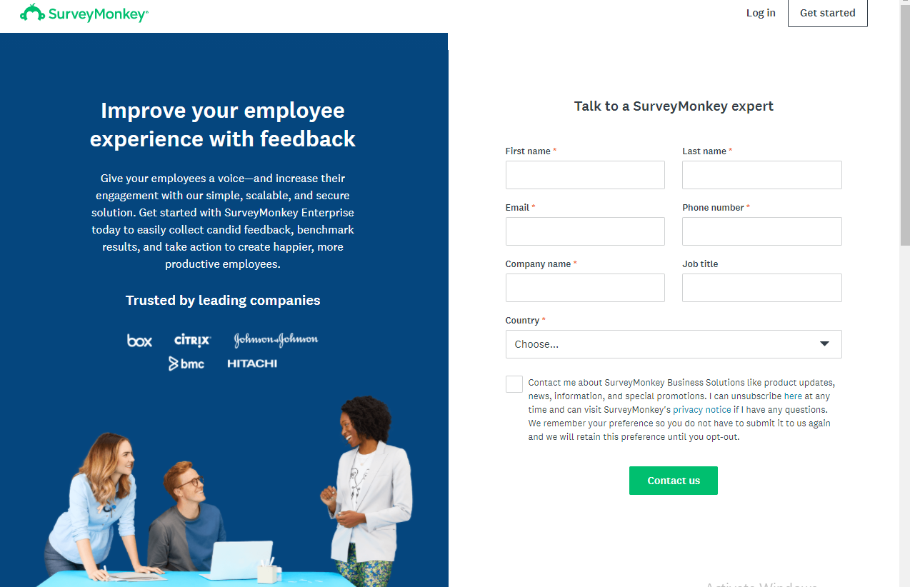

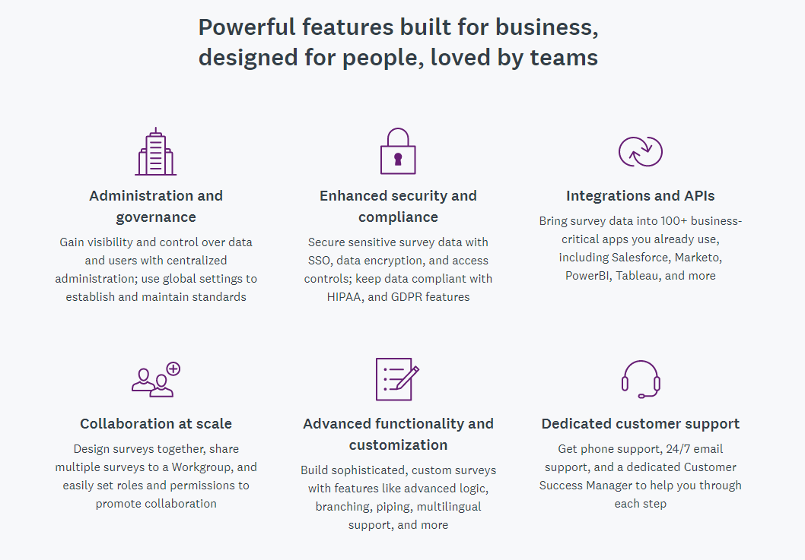

<https://www.wordstream.com/google-adwords?cid=Nurture_WS_Email_PPC_PerfTipNewsletter_AWGrader&utm_source=Email&utm_medium=Nurture&utm_campaign=PerfTipNewsletter&utm_content=PerfTip-Grader&utm_term=PPC&mkt_tok=NjIyLUJIQy01MTcAAAF7wQm9uCxRFJtDMFACy9WgIxYMfVBUje4bmmeOXa0ltvAOG0dFkM0lgWyeOunX_w3j92RpdhOfCW0BE-eYBCbuRx765fo6bVq0nLhQ9FGqoKNzlPo>



### Task 3 : Add poll feature in above home page giving two options

Give question with two option

Create table and add two columns yes and no

do you this training

Yes

No

When ever user select any one of the option it should save in database and fetch data from db and using javascript or ajax display poll percentage by replacing above question.